**Project Initialization and Planning Phase**

| Date | June 2024 |
| --- | --- |
| Team ID | Team-739859 |
| Project Name | Auto Insurance Fraud Detection Using Machine Learning |
| Maximum Marks | 3 Marks |

### Define Problem Statements(Insurance Fraud Analysis Template):

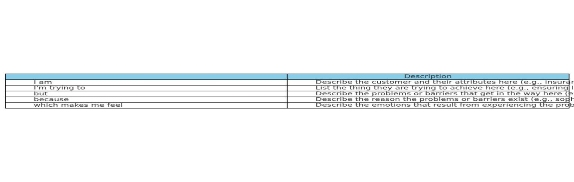

Create a problem statement to understand and effectively address the complexities of identifying and preventing fraudulent activities in auto insurance claims is crucial for ensuring fairness and trust among policyholders. Developing a robust solution that enhances fraud detection capabilities and streamlines the claims process is essential to meet the needs and expectations of insurance customers.

Reference: https://www.canva.com/design/DAGK7T6bAQs/iMnF98-TYsfrLtpFOTJ-Sg/view?utm_content=DAGK7T6bAQs&utm_campaign=designshare&utm_medium=link&utm_source=editor

**Example:**

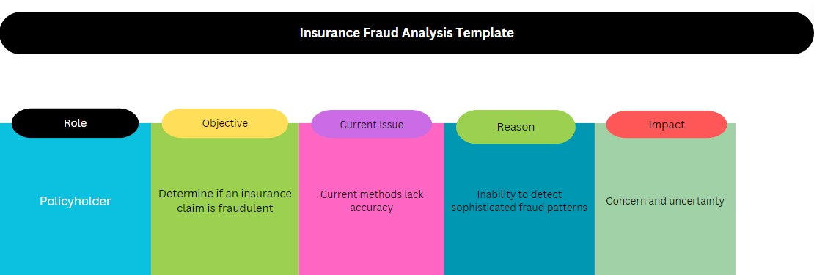

|  |  |  |  |  |  |  |  |
| --- | --- | --- | --- | --- | --- | --- | --- |
| **Problem**  **Statement (PS)** | **Role** | **Objective** | |  | | --- | |  |  |  | | --- | |  |   **Current Issue** | **Reason** | **Impact** |
| PS-1 | Policyholder | Determine if an insurance claim is fraudulent | Current methods lack accuracy | Inability to detect sophisticated fraud patterns | Concern and uncertainty |
| PS-2 | Insurance Company | Identify and prevent fraudulent insurance claims | Existing systems miss subtle fraud signals | Limited adaptive learning and real-time monitoring | Risk of financial losses |